|  |  |
| --- | --- |
| ­­ | **2015** |
|  | Wal-Mart Stores, Inc.  Anindya Sankar Dey  Omker Mahalanobish |

|  |
| --- |
| **[ShopLifting detection using A multiple sensor system]** |
| Walmart services millions of customers in a store every day, and because of the hugeness of the stores and because of the traffic each store handles on a daily basis, Walmart stores are very prone to shoplifting. Some latest reports indicate shoplifting to happen to a scale where Walmart loses around 1% of its revenue each year which is close to $3bn. Sensors like RFID are often attached to high end products, to prevent shoplifting. However there are several incidents where these sensors are removed from items in store by shoplifters. Our idea is to design a system using multiple (two at least) sensors that will interact with each other as well as with sensors in display fixtures & in store cameras to detect a shop lifting incident and communicate it back to store security team with visual proof for apprehending the shoplifter. |

Contents

SHOPLIFTING DETECTION USING A MULTIPLE SENSOR SYSTEM 2

Overview 2

Existing System Constraint 2

Solution 2

Overall Solution 2

System explanation diagram 4

Use Cases 4

## SHOPLIFTING DETECTION USING A MULTIPLE SENSOR SYSTEM

## Overview

* The idea is to detect shoplifting activity that happens by removal of anti-shoplifting sensors placed on items
* The detection system is based on
  1. At least two sensors put on the product itself
  2. Sensors in the display fixtures like shelves
  3. In-store cameras connected to a system
* Once a shop lifting incident is detected, store security will be alerted via mobile application or any other viable communication medium with valid proof of shop lifting
* The system is simple enough to be easily deployable with most components involving a onetime cost but has huge potential in stopping shop lifting of high end product.

## ­­Existing System Constraint

* Detecting & monitoring shoplifting is currently a fully manual process.
* The current system has no automation in place and monitoring is done manually and the surveillance is assisted through CCTV cameras and general monitoring by the employees. This has several shortcomings like huge dependence on individual judgment and efficiency.
* Currently, only *special asset protection associates* are responsible for prevention of shoplifting. They are mostly stationed at the exit and manually detect and target shoplifters.
* Strict guidelines are given to the employees to avoid stopping innocent customers. This also decreases the probability of stopping the probable shoplifters because the associates cannot stop shoplifters until they are sure about it. And as there is no evidence beforehand to suggest that a customer might be shoplifting, there is an increase in risk of shoplifting.
* High end products at the Walmart stores are equipped with an RFID tag, which if not removed can lead to alarm generation by RFID readers/scanners strategically placed at exits. But if RFID tag is removed from an item, it will not sound alarm at exit.
* RFID if removed from an item, also might not show up as a shop lift in store security system as it will just indicate that the product is in different location
* System can be designed which can sound an alarm on the item itself when RFID is removed from it, which again can easily be suppressed taking help from the immediate store environment.
* Also, it is impossible to identify the shoplifter at a real time basis using RFID tags.

## Solution­­

### Overall Solution

* The first target of the system is to identify the product, which is being shoplifted at a real-time basis. For this, we propose a system which uses set of multiple (at least two) sensors on each of the products, sensors on the display fixtures like shelves and in-store security cameras connected to the system.
* Each product will consist of multiple (at least two) sensors strategically placed at a fixed distance from each other, which will communicate with each other continuously.
* The sensors can communicate to each other using radio signal (RFID), Bluetooth or any other wireless medium.
* This fixed distance between the sensors, could only change if someone tries to tweak either the product under consideration or the sensors.
* Each of the sensors on the product will have a serial numbers and data on their fixed distance from each other is stored in the system database.
* The system will also have information about the item type which each of the sensor is placed viz. sensors with serial number 1234 and 4567 are placed on a Xbox 360
* Each of the sensor on the display unit will also have serial number and location in the store listed in a database.
* The display fixture’s sensor will primarily be responsible for receiving event alerts from the item sensors and communicating it back to the system
* The database will also list the closest security cameras to the sensor in the display fixture.
* As soon as the system detects that distance between the sensors on the products changes beyond a reasonable threshold, the system will detect this as a breach and trigger an event alert
* As soon as the system triggers an event alert, the product sensor which resulted in the trigger of alert will communicate with the nearest display fixture sensors which in turn communicate the event alert to the system
* The system upon receiving the alert will re-direct the closest security cameras to take pictures around the display sensor that reported the event alert
* The picture of from the in-store cameras, location of the display fixtures and the item information will then be sent to the store security team via mobile app or other communication medium for apprehending the shop lifter. The system will also keep the records in its database as well.
* The system will also be connected to the sensor screener/reader that will sound alert if anyone wants to take a product through exit without all the sensors removed from the product.

### System Explanation Diagram



## System Component Diagram

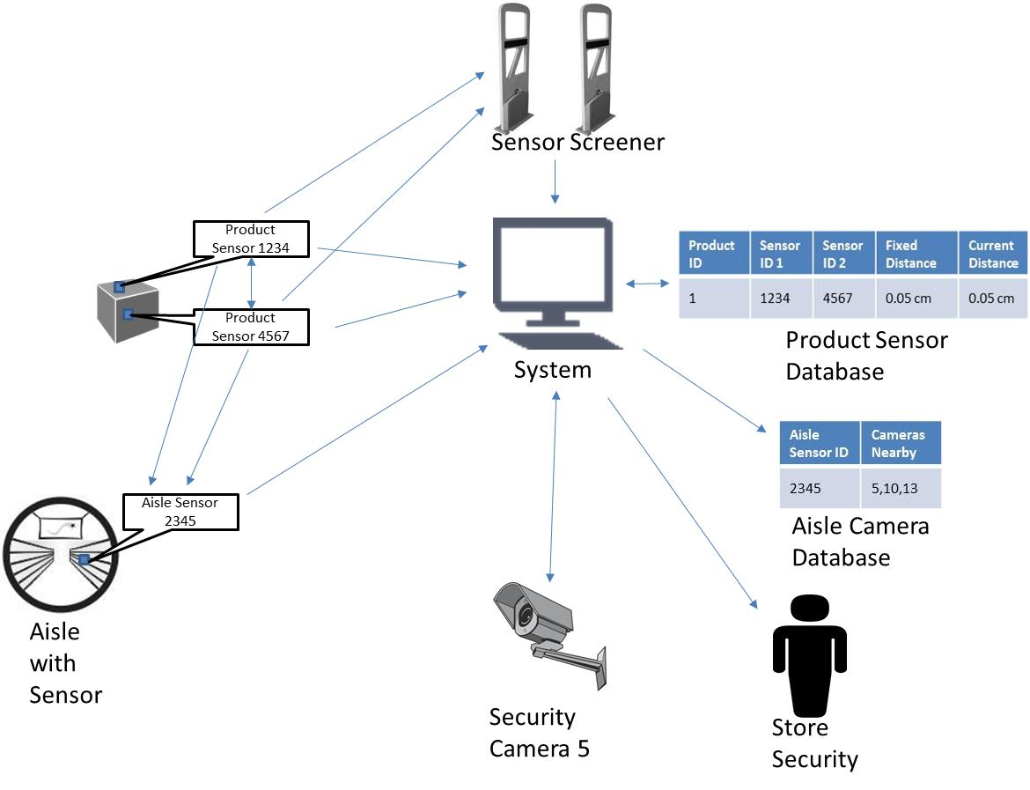

## Use Cases

* This shoplifting detection system is deployable in all Wal-Mart stores. The special asset protection associates currently work on experience and intuition. This algorithm is an add-on and not a replacement to this human skill.
* The system will help detecting customers who are shoplifting resulting in reduction of loss due to shoplifting even during peak sale hour when manual detection becomes very hard
* This will also decrease stopping of innocent customers, which will increase customer satisfaction.